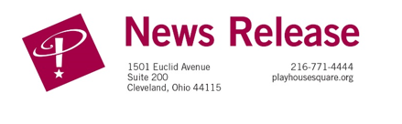
Media Contact: Leigh Ann Andreani
Phone: 216-640-8651
E-mail: leigh.andreani@playhousesquare.org

Media Assets available HERE
FOR IMMEDIATE RELEASE:

You Know You Wanna Sit With Us…
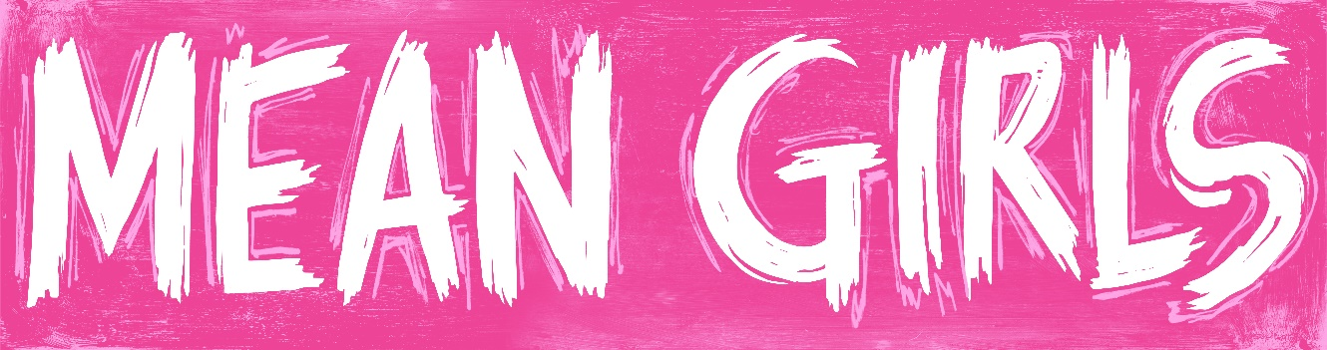

TICKETS ON SALE NOW

July 17, 2024 (CLEVELAND, OH) – Playhouse Square announced today that single tickets for the North American Tour of Mean Girls—the record-breaking new musical comedy adapted from the hit Paramount Pictures film—will go on sale July 17, 2024. Tickets will be available at playhousesquare.org or by calling 216-241-6000. Group orders of 10 or more may be placed by calling 216-640-8600.

Mean Girls features a book by nine-time Emmy Award® winner Tina Fey, based on her screenplay for the film; music by three-time Emmy Award® winner Jeff Richmond; lyrics by two-time Tony Award® nominee Nell Benjamin; and original direction and choreography by two-time Tony Award® winner Casey Nicholaw.

Mean Girls opened on Broadway in April 2018 to rave reviews at the August Wilson Theatre, following its world premiere at the National Theatre in Washington, DC, in the fall of 2017.

Cady Heron may have grown up on an African savanna, but nothing prepared her for the wild and vicious ways of her strange new home: suburban Illinois. How will this naïve newbie rise to the top of the popularity pecking order? By taking on The Plastics, a trio of lionized frenemies led by the charming but ruthless Regina George. But when Cady devises a plan to end Regina’s reign, she learns the hard way that you can’t cross a Queen Bee without getting stung.

New York Magazine calls Mean Girls “HILARIOUS! A smart, splashy new musical that delivers with immense energy, a wicked sense of humor and joyful inside-jokery.” Chicago Tribune said “Tina Fey writes FUNNIER, SMARTER, SHARPER satire than anyone else in the business.” People Magazine calls the show “FRESH, FUN AND INFECTIOUS – Jeff Richmond and Nell Benjamin’s songs keep the laughs coming!” The New York Daily News said Mean Girls “TICKLES THE EARS, EYES AND FUNNY BONE – the direction by Casey Nicholaw packs style, invention and red bull-force energy.” And, Entertainment Weekly calls it “A MARVEL: DAZZLING & HILARIOUS!”

Mean Girls (Original Broadway Cast Recording), produced by Atlantic Records, is now available.

Mean Girls is playing the KeyBank State Theatre at Playhouse Square for eight performances, October 29 - November 3, 2024. Show times are Tuesday - Friday at 7:30 p.m., Saturday at 1:30 p.m. and 7:30 p.m. and Sunday at 1:00 p.m. and 6:30 p.m. Tickets can be purchased online at playhousesquare.org or by calling 216-241- 6000. Group orders of 15 or more may be placed by calling 216-640-8600.

www.MeanGirlsOnTour.com
Follow the Mean Girls Tour on Instagram, Twitter, Facebook and TikTok.

Follow @PlayhouseSquare on Instagram, Facebook, TikTok and X

Media assets, including b-roll and production photos, available here.

# # #

Playhouse Square, home to the largest Broadway season ticket holder community in North America, is Northeast Ohio's destination for entertainment. A not-for-profit performing arts center, Playhouse Square is a champion of arts education and downtown Cleveland, and proud to be the home of The City Club of Cleveland, Cleveland Ballet, Cleveland International Film Festival, Cleveland Play House, Cleveland State University Department of Theatre and Dance, DANCECleveland, Great Lakes Theater and Tri-C JazzFest.

