

Media Contact: Liesl Davenport
Phone: 216-640-8677
Email: liesl.davenport@playhousesquare.org

FOR IMMEDIATE RELEASE:

JIM BRICKMAN BRINGS “COMFORT & JOY” TO CLEVELAND
SATURDAY, DECEMBER 20TH & SUNDAY, DECEMBER 22ND AT PLAYHOUSE SQUARE
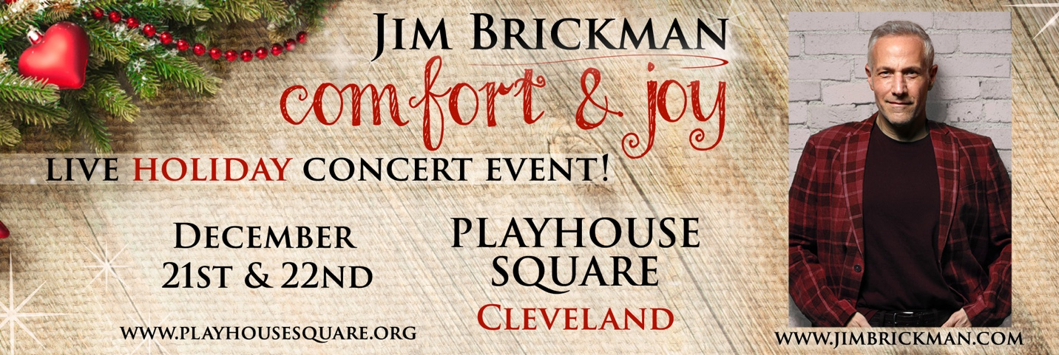
Piano sensation Jim Brickman returns to Cleveland this season with his brand-new holiday show “Comfort & Joy” at Playhouse Square on Saturday, December 21. Show times are Saturday at 2:00 p.m. and 8:00 p.m. and Sunday at 2:00 p.m.
Join Jim Brickman and friends this Christmas season for an unforgettable concert experience filled with music, laughter & heartwarming stories.
Audiences can expect a captivating blend of timeless holiday classics, along with Brickman's biggest hits like "The Gift," "Love of my Life," “Destiny,” “Valentine" and joyfully unexpected surprises
Escape with Jim Brickman to a magical atmosphere that brings friends and family together to celebrate the true spirit of Christmas.

To keep up with Jim Brickman, visit his website and click the social bar linked below.
Facebook | Instagram | YouTube
“Sensational” – Chicago Sun Times
“Incredibly easy and Uplifting” – Parade
“The premier romantic soloist of his generation.” – All Music Guide
JIM BRICKMAN
Jim Brickman is the best-selling solo pianist of our time, earning 21 number one albums, 32 Top 20 radio hits, and two Grammy nominations. His first album release was 1995’s “No Words,” and he’s gone on to sell eight million albums worldwide. His star-studded vocal collaborations have crossed genres to feature luminaries like Martina McBride, Donny Osmond, Kenny Rogers, Olivia Newton-John, Johnny Mathis and Kenny Loggins amongst many others. He’s written three best-selling books, starred in four TV concert specials, and is in the 24th season of hosting the popular syndicated radio show: “The Jim Brickman Show

Tickets can be purchased online at www.playhousesquare.org or by phone at 216-241-6000.

# # #

Playhouse Square, home to the largest Broadway season ticket holder community in North America, is Northeast Ohio's destination for entertainment. A not-for-profit performing arts center, Playhouse Square is a champion of arts education and downtown Cleveland, and proud to be the home of The City Club of Cleveland, Cleveland Ballet, Cleveland International Film Festival, Cleveland Play House, Cleveland State University Department of Theatre and Dance, DANCECleveland, Great Lakes Theater and Tri-C JazzFest.

