**Media Contact:** Liesl Davenport

**Phone:** 216-640-8677

**Email:** [liesl.davenport@playhousesquare.org](mailto:liesl.davenport@playhousesquare.org)

**FOR IMMEDIATE RELEASE:**

**Joe Bonamassa Announces Spring U.S. 2025 Tour,**

**On Heels of Record-Setting Billboard Debut**

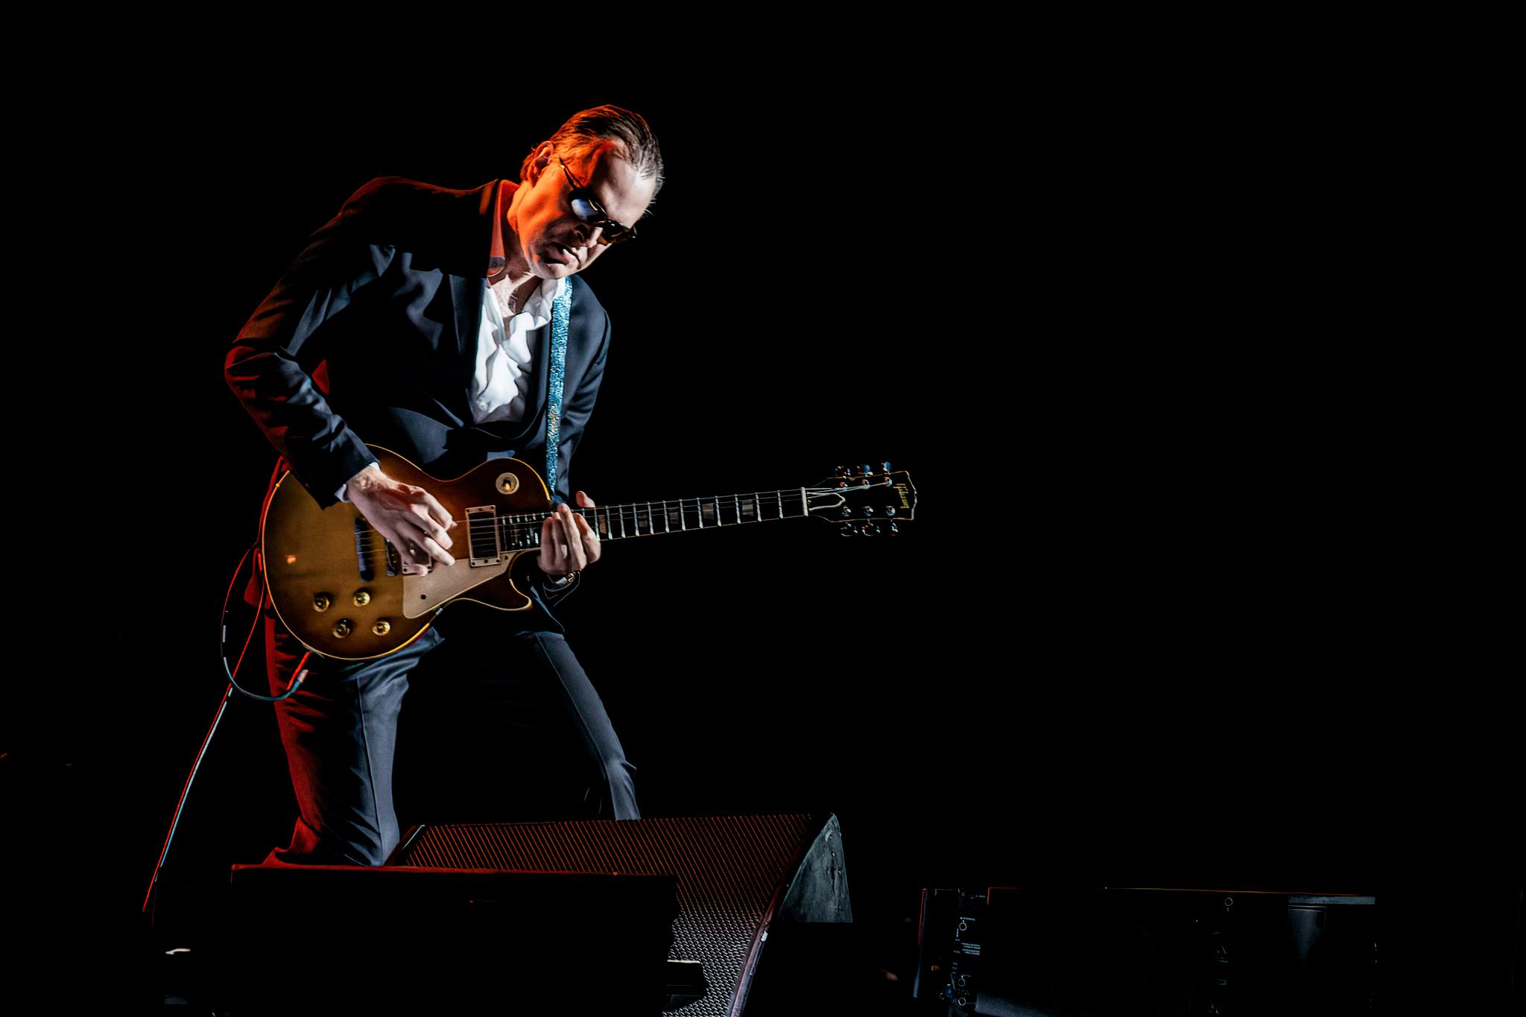

*Photo credit: Haluk Gurer Birmingham*

CLEVELAND, OH- Blues-rock titan **Joe Bonamassa** is thrilled to announce his **Spring U.S. 2025 Tour**, set to captivate audiences from coast-to-coast with the world-renowned guitarist’s electrifying live performances. The tour kicks off onFebruary 16, 2025, at Climate Pledge Arena in Seattle, WA, and will stop in Cleveland at Playhouse Square on SaturdayFebruary 22, 2025, at 8:00 p.m. Tickets can be purchased online at [www.playhousesquare.org](http://www.playhousesquare.org) or by phone at 216-241-6000.

The announcement of Bonamassa’s **Spring U.S. 2025 Tour** follows the release of his acclaimed live concert film and album, ***Live At The Hollywood Bowl With Orchestra***, which **debuted at #1 on the Billboard Blues Albums** chart, further solidifying Bonamassa’s record for **the most #1s in the chart’s history**. This latest release also debuted at **#1** on the **Billboard Classical Album and Classical Crossover Album charts and #17 on the Top Album Sales chart.** The project captures the grandeur of Bonamassa’s historic performance at the iconic Hollywood Bowl, featuring orchestral arrangements that elevate his signature blues-rock sound to new heights. Fans can order **Live At The Hollywood Bowl With Orchestra** [**NOW**](https://joeb.me/OrderLFTHBWO).

The **Spring 2025 Tour** will take Bonamassa through a diverse array of venues, from the vibrant **Fox Theatre** in **Atlanta, GA**, to the historic **Beacon Theatre** in **New York City, NY**. Each show promises to deliver a powerful blend of blues and rock, showcasing Joe’s extraordinary guitar prowess and soulful vocals. The tour will visit a variety of iconic theaters and arenas, ensuring an intimate yet grand experience for concert-goers.

Before embarking on the **Spring 2025 Tour**, Bonamassa will be busy with an extensive schedule of performances. Next month, he kicks off the highly anticipated **Blues Deluxe Tour**, celebrating his seminal albums ***Blues Deluxe*** and ***Blues Deluxe Vol. 2***. This summer tour includes 18 cities and features a mix of fan favorites and deep tracks, promising unforgettable shows for blues enthusiasts. Never one to slow down, Bonamassa will also be **on the road this fall** for a series of performances across the U.S., continuing to deliver his unmatched live experience to fans nationwide.

Bonamassa's impact on the blues-rock genre is immeasurable. ***Guitar World*** has hailed him as "the world's biggest blues guitarist," a testament to his skill, influence, and role in bringing blues rock to the forefront of the music scene. With a career spanning over three decades, Bonamassa has consistently captivated audiences around the globe with his dynamic live performances and musical ingenuity.

In addition to his musical releases and touring, Bonamassa remains dedicated to his philanthropic efforts through the **Keeping The Blues Alive Foundation (KTBA)**. With the success of KTBA’s numerous programs, including the Fueling Musicians Program and virtual blues education initiatives, the foundation has raised over 2.7 million in fundraising and continues to grow. To date, the foundation has impacted over 100,000 students across the United States and provided essential support to hundreds of musicians.

**U.S. SPRING 2025 TOUR (JUST ANNOUNCED)**

February 16 - Seattle, WA - Climate Pledge Arena

February 19 - Milwaukee, WI - The Riverside Theater

February 21 - Chicago, IL - The Chicago Theatre

February 22 - Cleveland, OH - Playhouse Square

February 25 - Buffalo, NY - Shea’s Buffalo Theatre

February 27th - New York City, NY - Beacon Theatre

February 28th - Boston, MA - MGM Music Hall at Fenway

March 1 - Mashantucket, CT - Foxwoods Resort & Casino

March 3 - Easton, PA - State Theatre

March 5 - Charleston, WV - Clay Center

March 7 - Cherokee, NC - Harrah’s Cherokee Casino Resort Event Center

March 8 - Atlanta, GA - Fox Theatre

March 10 - Chattanooga, TN - Soldiers & Sailors Memorial Auditorium

March 12 - Greensboro, NC - Steven Tanger Center

March 14 - Charlotte, NC - Ovens Auditorium

March 15 - St. Augustine, FL - The St. Augustine Amphitheatre

March 16 - Mobile, AL - Saenger Theatre

March 18 - Evans, GA - Columbia County Performing Arts Center

March 19 - Melbourne, FL - The King Center

**ABOUT JOE BONAMASSA**

Blues-rock superstar Joe Bonamassa is one of the most celebrated performing musicians of today. As a three-time GRAMMY-nominated artist and 15x Blues Music Award Nominee (4-time winner), he achieved his 28th No. 1 album on the Billboard Blues Chart with his most recent live album and concert film, *Live at the Hollywood Bowl With Orchestra*. Only in his mid-40s, Bonamassa has become a living legend with an astounding multi-genre catalog. He has released more than 40 albums, including studio and live recordings, as well as collaborative albums with his adventurous side projects: Black Country Communion and Rock Candy Funk Party.

A prolific writer who is always on the hunt to expand his eclectic musical horizons, Bonamassa has a limitless work ethic whether it’s in the studio, on the road, or working with other artists to spur new music. In recent years, he has produced an immense number of albums including Joanne Shaw Taylor, Marc Broussard, Larry McCray, Jimmy Hall, and others for his independent label KTBA Records, and has also recently launched Journeyman LLC, a full-service artist management, record label, concert promotion, and marketing company that builds awareness for independent artists worldwide.

*# # #*

Playhouse Square, home to the largest Broadway season ticket holder community in North America, is Northeast Ohio's destination for entertainment. A not-for-profit performing arts center, Playhouse Square is a champion of arts education and downtown Cleveland, and proud to be the home of The City Club of Cleveland, Cleveland Ballet, Cleveland International Film Festival, Cleveland Play House, Cleveland State University Department of Theatre and Dance, DANCECleveland, Great Lakes Theater and Tri-C JazzFest.