

Media Contact: Liesl Davenport
Phone: 216-640-8677
Email: liesl.davenport@playhousesquare.org

FOR IMMEDIATE RELEASE:

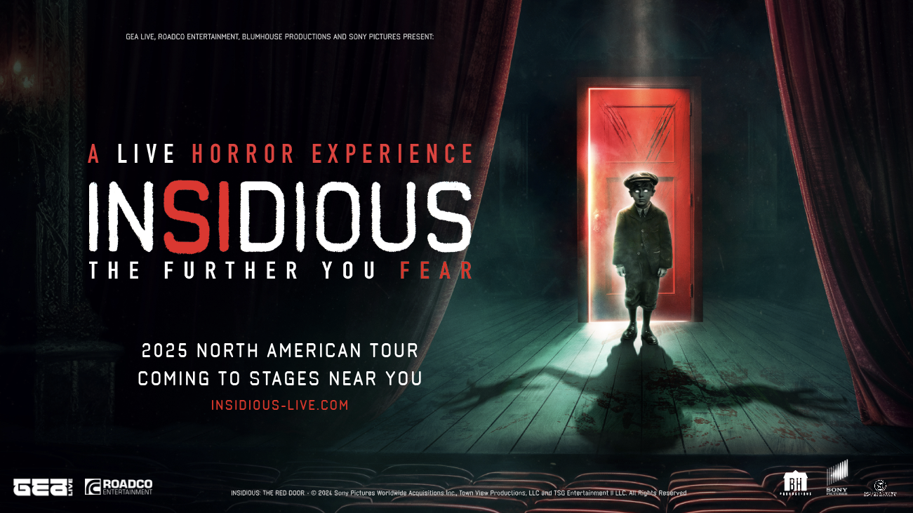

IMMERSIVE THEATRICAL HORROR EXPERIENCE BASED ON “INSIDIOUS” FILM FRANCHISE TO VISIT
PLAYHOUSE SQUARE ON FEBRUARY 1, 2025

“INSIDIOUS: THE FURTHER YOU FEAR” Reimagines the Blumhouse Film Franchise
– One of the Most Successful Film Horror Franchises of All Time –
Live On Stage

Watch the trailer here.

Press Assets

Cleveland, OH – Brace yourself for the scare of a lifetime, as the world of Insidious jumps off the screen and directly into your theater seat with “INSIDIOUS: THE FURTHER YOU FEAR” – a live immersive horror experience that will bring your darkest fears to life right before your eyes, based on the box office hit horror film franchise from Blumhouse, director James Wan, and writer Leigh Whannell. GEA Live, Blumhouse, Sony Pictures Entertainment, and RoadCo Entertainment have joined forces to unveil a spine-tingling, live immersive show that will haunt 80+ seated theaters across North America including Playhouse Square on February 1, 2025. Tickets are on sale now at playhousesquare.org.

“INSIDIOUS: THE FURTHER YOU FEAR” is a heart-pounding live theatrical experience where the lines between reality and fiction blur, constantly challenging what’s real and what’s imagined, what’s safe and what’s dangerous. This groundbreaking immersive experience is meticulously crafted to always keep the audience on edge, with no fourth wall to separate them -or protect them- from the unfolding terror. Each attendee will go face-to-face with the protagonists, making the audience an integral character in the chilling story as it unravels.

“We have brought some of the most respected names in the horror and entertainment industries together to make this groundbreaking show possible and ensure a hauntingly unforgettable experience for audiences everywhere,” says Floris Douwes from GEA Live. “We’re excited to bring the eerie and otherworldly thrills of 'Insidious' to cities around the country,” says Co-Director Toby Park. Park, who is also composing the original music for the show, and Co-Director Aitor Basauri are artistic directors for Spymonkey, and serve as creative directors for “INSIDIOUS: THE FURTHER YOU FEAR.”

“Bringing audiences deeper into The Further with this live experience has been an exciting challenge, and I’m really looking forward to seeing how they respond,” said Jason Blum, Founder/CEO, Blumhouse. “Insidious is one of our most popular franchises, with a sixth installment premiering next year, and this is a fresh and frightening new way for fans to experience it.”

“INSIDIOUS: THE FURTHER YOU FEAR” is an exciting new story conceived within the Insidious universe. Hosted as a live event by the “real” Specs and Tucker, the actual paranormal investigators who inspired the first movie, the “Spectral Sightings Road Show” soon takes a turn for the terrifying. As the infamous duo desperately try to prove they are legitimate ghost-hunters, things start to become very Insidious when a paranormal demonstration goes wrong and dark forces are inadvertently unleashed. Trapped in a genuinely haunted theatre, with something truly sinister lurking back-stage, the audience will find themselves under attack from such iconic characters as the Bride in Black, the Wheezing Man and, of course, the terrifying Lipstick Faced Demon. But what’s real? What’s the show? And who are you really sitting next to?

The house is full. The stage is set. And the Red Door is about to open.

The iconic “Insidious” franchise, consistently gaining momentum over the years, is a box office sensation generating more than $742 million in revenue across five highly successful films. The growing legion of fans includes an active community of five million social media followers. However, while the show is a must for Insidious fans, it’s also created for those who don’t know the films, particularly those who love a fun, thrill-filled night out at the theatre.

For more information, visit www.insidious-live.com and follow Insidious on Facebook, Instagram, and X.

About GEA Live
Since its inception in 2003, GEA Live has delivered innovative live entertainment projects in more than 40 countries, becoming a global leader in the location-based entertainment sector. GEA Live has closely cooperated with the legend Maestro Ennio Morricone (representing him exclusively for all live touring) as well as with icons of music film industry such as James Newton Howard, Giorgio Moroder and George Fenton. In addition to producing live cinematic experiences such as the Johnny Cash Official Concert Experience or Elvis Live On Screen, GEA Live has produced live screenings with orchestra and choir of major motion pictures such as Spider-Man, Dirty Dancing, The Godfather, Titanic, La La Land, Twilight, The Hunger Games, Paddington and Amadeus. This journey has led to fruitful collaborations with renowned studios and IP giants such as Lionsgate, Viacom, Sony Pictures, Warner Brothers, and other global leaders in the branded entertainment landscape, earning GEA Live its well-deserved position as the most reliable and trusted partner for location-based entertainment projects worldwide.

About RoadCo
RoadCo Entertainment is a producing and distribution agency specializing in live entertainment experiences. Formed in 2020, RoadCo is a collaboration between Sony Music Entertainment and independent touring entrepreneurs Stephen Lindsay and Brett Sirota, co-founders of The Road Company, a leading independent theatrical booking agency. RoadCo represents a broad roster of live events based on popular brands and pre-existing intellectual properties, as well as all-new immersive, interactive attractions for viewers of all ages.

About Spymonkey
Spymonkey is the UK’s leading physical comedy ensemble led by co-artistic directors Aitor Basauri and Toby Park. The have been making ‘Theatre of the Funny’ since 1998. With their dark, edgy physical comedy rooted ‘somewhere between Monty Python, the Marx Brothers and Samuel Beckett’ (The Houston Chronicle), Spymonkey have proved to be a truly international phenomenon, enjoyed by and accessible to, a wide range of international audiences from Cirque du Soleil Las Vegas to Sydney Opera House, from London’s West End to Just For Laughs Montreal. Recent years have seen the company growing in new directions as their creative focus has shifted from performing to creating and producing Spymonkey shows, as well as an extensive international training programme. In 2023 they directed Orpheus in the Underworld, a first full-scale opera at the Volksoper in Vienna, and their first show for children, Hairy in London. Spymonkey also have an extensive programme of workshops and training opportunities in the UK and abroad, particularly through a thriving network in the USA.
Spymonkey’s associate, theatre and screenwriter, and a self-confirmed horror film obsessive Carl Grose will be co-writing Insidious: The Further You Fear.

About Blumhouse
Blumhouse is the driving force in horror, producing over 200 movies and television series with theatrical grosses of almost $6 billion in global box office. Blumhouse is home to the highest number of ongoing franchises of any studio, including Halloween, The Purge, The Black Phone, Paranormal Activity, The Exorcist, Insidious, M3GAN, and Five Nights at Freddy's, along with iconic films from cinematic visionaries including Jordan Peele's Get Out, Damien Chazelle's Whiplash and Spike Lee's BlacKkKlansman. In January 2024, Blumhouse merged with James Wan’s Atomic Monster, which has produced its own successful film franchises including The Conjuring, Aquaman, Annabelle, The Nun and Saw.

In addition to film, Blumhouse produces provocative scripted and unscripted television series and documentaries, including the upcoming original series The Sticky, produced by Jamie Lee Curtis for Amazon; The Bondsman, starring Kevin Bacon and from creator Grainger David and showrunner Erik Oleson, also for Amazon; Worst Roommate Ever for Netflix; and The Jinx for HBO. The company also recently launched a games division.

Blumhouse was honored by Fast Company as one of its Most Innovative Companies in 2024 and one of its Brands That Matter in 2023. The company is investing in its brand development and connection with audiences through its consistent presence at Universal Studios’ annual Halloween Horror Nights, its first Halfway to Halloween Film Festival with AMC and its upcoming transformation of an exhibit space at the iconic Stanley Hotel from The Shining.

About Sony Pictures Entertainment
Sony Pictures Entertainment (SPE) is a subsidiary of Tokyo-based Sony Group Corporation. SPE's global operations encompass motion picture production, acquisition, and distribution; television production, acquisition, and distribution; television networks; digital content creation and distribution; operation of studio facilities; and development of new entertainment products, services and technologies. Sony Pictures Television operates dozens of wholly-owned or joint-venture production companies around the world. SPE’s Motion Picture Group production organizations include Columbia Pictures, Screen Gems, TriStar Pictures, 3000 Pictures, Sony Pictures Animation, Stage 6 Films, AFFIRM Films, Sony Pictures International Productions, and Sony Pictures Classics.

# # #

Playhouse Square, home to the largest Broadway season ticket holder community in North America, is Northeast Ohio's destination for entertainment. A not-for-profit performing arts center, Playhouse Square is a champion of arts education and downtown Cleveland, and proud to be the home of The City Club of Cleveland, Cleveland Ballet, Cleveland International Film Festival, Cleveland Play House, Cleveland State University Department of Theatre and Dance, DANCECleveland, Great Lakes Theater and Tri-C JazzFest.

