**FOR IMMEDIATE RELEASE:**

**Media Contact:** Liesl Davenport

**Phone:** 216-640-8677

**Email:** [liesl.davenport@playhousesquare.org](mailto:liesl.davenport@playhousesquare.org)

“Authentic and Exciting” | “A Real Treat” | “Amazing” | “Enchanting” | “Simply Incredible”

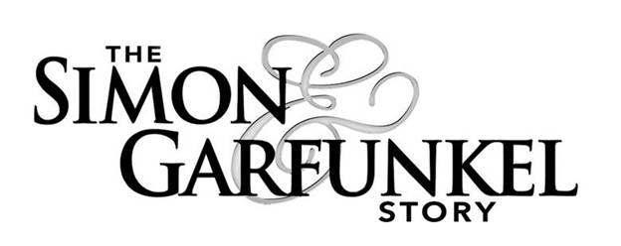

**The Simon & Garfunkel Story 2025 North American Tour Visits Playhouse Square on March 20, 2025**

***Tickets on Sale Now at*** [***PlayhouseSquare.org***](https://www.playhousesquare.org)

[***Media Assets***](https://drive.google.com/drive/folders/1DAAU3ZBZ8asbyR0kTKkXOSfqHpJyvXZk?usp=sharing)

**Cleveland, OH –** Relive the magic of the legendary folk-rock duo! Theinternationally-acclaimed hit theater show **The Simon & Garfunkel Story** ([www.thesimonandgarfunkelstory.com](http://www.thesimonandgarfunkelstory.comr)) returns to the road in 2025 with a North American tour to nearly 60 U.S. cities. Stopping at Cleveland’s Playhouse Square on March 20, 2025, one show only, the immersive concert-style tribute show, complete with nostalgia-inducing, unforgettable hits, will recreate the magic and authenticity of Paul Simon and Art Garfunkel live on stage and chronicles the amazing journey of the iconic, GRAMMY-award winning act.

Tickets are on sale now and available at [www.playhousesquare.org](http://www.playhousesquare.org). **The Simon & Garfunkel Story** will play Playhouse Square on March 20, 2025 at 8:00 PM.Tickets are available online at playhousesquare.org or by calling 216-241-6000.

Fans aren’t the only ones blown away by **The** **Simon & Garfunkel Story**. Earlier this year immediately following a performance in Long Island, Art Garfunkel himself rushed the stage, grabbed the microphone, and declared, “What a great f------ show!” before leaving the audience in awe once again. If the legend himself is a fan, you know this is a tour you won’t want to miss.

**The Simon & Garfunkel Story** covers the duo’s humble beginnings as Tom & Jerry, to their incredible success as one of the best-selling music groups of the ‘60s, as well as their dramatic split in 1970. The Simon & Garfunkel Story culminates with the pair’s famous “The Concert in Central Park” reunion in 1981 which had more than half a million fans in attendance. The show features a set list of nearly 30 songs and uses state-of-the-art video projection, photos and original film footage. A full live band will perform all of the hits including “Mrs. Robinson,” “Cecilia,” “Bridge Over Troubled Water,” “Homeward Bound” and many more complete with the unmistakably perfect harmonies that will transport audiences down memory lane.

With more than 100 million album sales since 1965, Simon & Garfunkel’s unforgettable songs and poetic lyrics poignantly captured the times made them one of the most successful folk-rock duos of all time. Over the years, they won 10 GRAMMY Awards and were inducted into the Rock and Roll Hall of Fame in 1990. In 1977, the Brit Awards honored their “Bridge Over Troubled Water” album with Best International Album. In 2003, Simon & Garfunkel were awarded a Grammy Lifetime Achievement Award and the following year saw their “The Sound of Silence” awarded a Grammy Hall of Fame Award.

For tour dates, tickets and more information about **The Simon & Garfunkel Story**, visit [www.thesimonandgarfunkelstory.com](https://www.thesimonandgarfunkelstory.com/).

**ABOUT RUCKUS ENTERTAINMENT (Producers):**

Ruckus Entertainment, based in Los Angeles and formed in 2022, brings together veteran entertainment producers Alison Spiriti, Justin Sudds, Dean Elliott and Ralph Schmidtke who are collectively responsible for producing over 100 touring productions seen by millions around the world. Their burgeoning production company brings audiences world-class concerts and live events and is focused on celebrating the history and music behind iconic, globally recognized musical artists. Current productions include The Simon & Garfunkel Story, The Life and Music of George Michael and The British Invasion.

###

Playhouse Square, home to the largest Broadway season ticket holder community in North America, is Northeast Ohio's destination for entertainment. A not-for-profit performing arts center, Playhouse Square is a champion of arts education and downtown Cleveland, and proud to be the home of The City Club of Cleveland, Cleveland Ballet, Cleveland International Film Festival, Cleveland Play House, Cleveland State University Department of Theatre and Dance, DANCECleveland, Great Lakes Theater and Tri-C JazzFest.