**FOR IMMEDIATE RELEASE:**

**Media Contact:** Liesl Davenport

**Phone:** 216-640-8677

**Email:** [liesl.davenport@playhousesquare.org](mailto:liesl.davenport@playhousesquare.org)

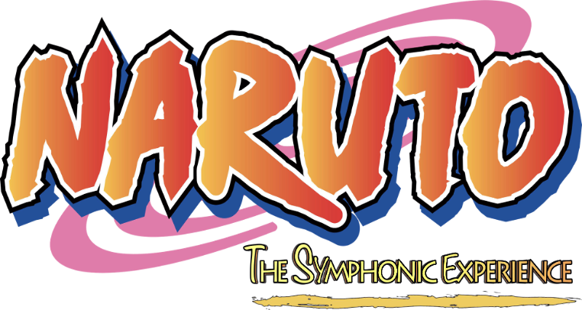

**NARUTO THE SYMPHONIC EXPERIENCE NORTH AMERICAN TOUR COMES TO PLAYHOUSE SQUARE ON MARCH 14**

***For the First Time Ever, Audiences in More Than 60 Cities Will See a Live Orchestra Perform the Most Iconic Songs and Themes from the Naruto Animated Series, Live-to-Picture, as Scenes Play Out on a Full-Size Cinema Screen***

***Tickets are On Sale Now at*** [***PlayhouseSquare.org***](https://www.playhousesquare.org)

[***Press Assets***](https://drive.google.com/drive/folders/197XfpX1tJcrue4W00tJqzt6Sy5y3JKqF?usp=sharing)

**Cleveland, OH –**  GEA Live, Un Pour Tous Productions, and RoadCo Entertainment today announced **Naruto The Symphonic Experience** ([www.narutoinconcert.com](http://www.narutoinconcert.com)),fresh off its successful European tour seen by more than 60,000 fans, will visit more than 60 cities on its first North American tour including a stop at Playhouse Square on March 14. For the first time ever, audiences will get their chance to see an original, unforgettable two-hour feature film (shown with subtitles) meticulously created by Julien Vallespi and Quentin Benayoun from the first 220 original episodes of the beloved Naruto animated series that is currently celebrating the 20th anniversary of its original TV anime adaptation. The orchestra will perform the most iconic songs and themes from the series, live-to-picture, as scenes are projected on a full-size, HD cinema screen.

Tickets are on sale now at [playhousesquare.org](http://www.playhousesquare.org/) and by phone at 216-241-6000.

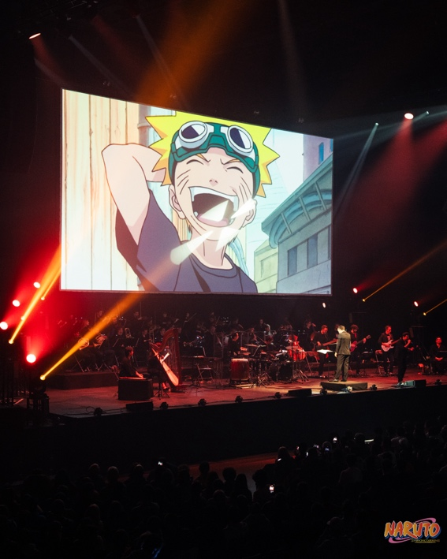

"We invite Naruto fans to celebrate Naruto with this unique, live-to-picture experience. We created a two-hour film enhanced with a live, symphonic orchestra because the soundtrack plays such a huge role in the anime’s success and is praised by the legions of fans time and time again,” says producer Julien Vallespi. “The original score, composed by Toshio Masuda is a perfect blend between pop and rock arrangements as well as traditional Japanese instruments like the Shakuhachi and Shamisen.”

With worldwide popularity and more than 250 million copies sold, Naruto, by Masashi Kishimoto, is a shonen manga that started in Weekly Shonen Jump in 1999 and concluded in 2014 after 700 chapters. The story revolves around Naruto Uzumaki, a ninja who overcomes his past and battles countless rivals to eventually become the Hokage, the leader of the Village Hidden in the Leaves.

The anime began airing on the TV Tokyo network in 2002, followed by Naruto Shippuden (2007–2017). The 20th anniversary of the TV broadcast was commemorated in October 2022. Being distributed worldwide immediately after broadcast in Japan has made Naruto an internationally celebrated series beloved by people all over the world. Eleven animated feature films have also been released, as well as apps, games, and merchandise, art exhibitions, 2.5D musicals, music festivals, and Kabuki performances.

Vallespi spent months selecting the best and most iconic moments from more than 70 hours of the first 220 episodes, identifying and choosing appropriate narrative arcs, and combining the best dialogue, scenes, and musical sequences. Significant synchronization work had to be done to match the score to the film, and to make everything as smooth as possible for the conductor and the musicians. “This symphonic-rock show is a tribute to Kishimoto’s anime, and Masuda’s music,” says Vallespi.

For more information about **Naruto The Symphonic Experience**, tour dates, and tickets, please visit [www.narutoinconcert.com](http://www.narutoinconcert.com) and follow [@naruto_symphonic_experience](https://www.instagram.com/naruto_symphonic_experience) on Instagram, and follow @OfficialVIZMedia on [Facebook](https://www.facebook.com/OfficialVIZMedia), and @VIZMedia on [Instagram](https://www.instagram.com/vizmedia/) and [X](https://x.com/VIZMedia).

**About GEA Live**

Since its inception in 2003, GEA Live has delivered innovative live entertainment projects in more than 40 countries, becoming a global leader in the location-based entertainment sector. GEA Live has closely cooperated with the legend Maestro Ennio Morricone (representing him exclusively for all live touring) as well as with icons of music film industry such as James Newton Howard, Giorgio Moroder and George Fenton. In addition to producing live cinematic experiences such as the Johnny Cash Official Concert Experience or Elvis Live On Screen, GEA Live has produced live screenings with orchestra and choir of major motion pictures such as Spider-Man, Dirty Dancing, The Godfather, Titanic, La La Land, Twilight, The Hunger Games, Paddington and Amadeus. This journey has led to fruitful collaborations with renowned studios and IP giants such as Lionsgate, Viacom, Sony Pictures, Warner Brothers, and other global leaders in the branded entertainment landscape, earning GEA Live its well-deserved position as the most reliable and trusted partner for location-based entertainment projects worldwide.

**About Un Pour Tous Productions**

Un Pour Tous Productions, co-founded by Rémi Préchac and Julien Vallespi in 2021, is a production company specializing in the acquisition and development of strong licenses (Lucky Luke, Naruto, Les Mystérieuses Cités d'Or...) in order to adapt them into Musicals, Films or TV Series. Lucky Luke is the structure's first ambitious series. Un Pour Tous Productions is a subsidiary of Abside Groupe, which also operates the Montjoie studios (winner of the 2030 stimulus plan) and aims to become a new industrial player in the creative sector. Un Pour Tous Productions is one of the driving forces behind this dynamic.

**About RoadCo Entertainment**

RoadCo Entertainment, formed in 2020, is a producing and distribution agency specializing in live entertainment experiences. A collaboration between Sony Music Entertainment and independent touring entrepreneurs Stephen Lindsay and Brett Sirota, RoadCo represents a broad roster of live events based on popular brands and intellectual properties, as well as all-new immersive and interactive attractions for audiences of all ages.

**About VIZ Media**

Wherever manga and anime fans are, we are! VIZ Media is No. 1 in Japanese pop culture, introducing fans to what’s now, new, and next. Home to the world’s most influential and groundbreaking storytellers and artists, who today drive multiple industries from publishing and animation to film and gaming. If it’s big in Japan, you can find it at VIZ.

VIZ Media is proudly certified as a Most Loved Workplace® in America and Inc Magazine’s 2023 Best Workplace. For more information on VIZ Media visithttps://www.viz.com/ and follow @OfficialVIZMedia on [Facebook](https://www.facebook.com/OfficialVIZMedia), and @VIZMedia on [Instagram](https://www.instagram.com/vizmedia/) and [X](https://x.com/VIZMedia).

# # #

Playhouse Square, home to the largest Broadway season ticket holder community in North America, is Northeast Ohio's destination for entertainment. A not-for-profit performing arts center, Playhouse Square is a champion of arts education and downtown Cleveland, and proud to be the home of The City Club of Cleveland, Cleveland Ballet, Cleveland International Film Festival, Cleveland Play House, Cleveland State University Department of Theatre and Dance, DANCECleveland, Great Lakes Theater and Tri-C JazzFest.