

Media Contact: Liesl Davenport
Phone: 216-640-8677
Email: liesl.davenport@playhousesquare.org

FOR IMMEDIATE RELEASE:

Click here to download, photos, b-roll, etc. Media Assets.

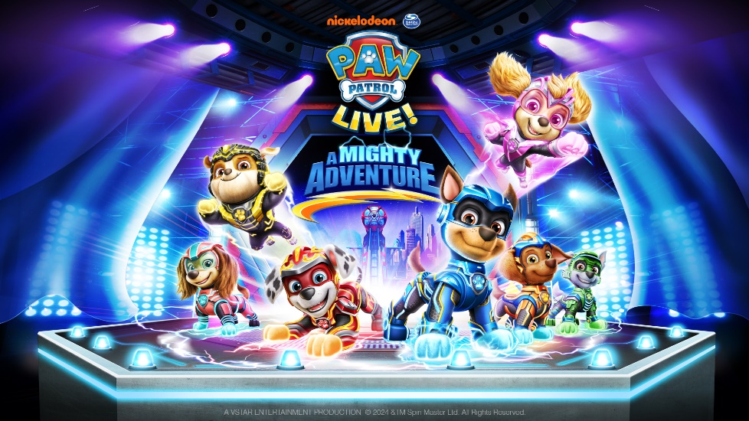

THE PAW PATROL® UNLEASH THEIR SUPERPOWERS IN NICKELODEON AND VSTAR ENTERTAINMENT GROUP’S
BRAND-NEW LIVE STAGE SHOW
PAW PATROL LIVE! “A MIGHTY ADVENTURE”

The Pack is Back for five shows at Playhouse Square February 8 & 9!
Tickets are on sale now at playhousesquare.org!

CLEVELAND, OH – Nickelodeon and VStar Entertainment Group proudly present PAW Patrol Live! “A Mighty Adventure.” This all-new live stage show picks up where Paramount Pictures’ #1 box office hit PAW Patrol: The Mighty Movie left off, promising a high-stakes super-powered adventure for fans of all ages. Audiences will join the “PAW-some” pack in Adventure City and witness the pups charged up like never before, as they work together to super-save the day. With heroic action, catchy tunes, and “bark-loads” of interactive fun, this electrifying new experience is sure to leave tails wagging and audiences cheering!

PAW Patrol Live! “A Mighty Adventure” is based on the top rated animated preschool series PAW Patrol, airing on Nickelodeon and produced by Spin Master Entertainment. Tickets for all five performances are on sale now and may be purchased online at playhousesquare.org or by phone at 216-241-6000.

PAW Patrol Live! “A Mighty Adventure” follows Chase, Marshall, Skye and the rest of the pack after they save Adventure City with their Mighty Pup Powers. Now it’s time for the “PAW-some-est” street party ever. But when supervillain scientist Victoria Vance feels left out of the festivities, she unleashes her latest invention to crash the party and steal the spotlight for herself! Can the Mighty Pups, armed with their super-charged powers, outsmart Victoria to ensure Adventure City’s biggest bash goes off without a hitch? It’ll take the power of paw-sitivity and mighty teamwork to foil her plans and keep the party pumping!

“A Mighty Adventure” marks the fourth PAW Patrol Live! touring production, created by VStar Entertainment Group and Nickelodeon. Since its debut in 2016, PAW Patrol Live! shows have been seen by 6 million people, providing families in over 40 countries with lifelong memories and spectacular theater experiences.

SHOW DETAILS IN CLEVELAND:

When: Saturday, February 8, 2025 10:00 a.m., 2:00 p.m., & 6:00 p.m.

Sunday, February 9, 2025 11:00 a.m. & 3:00 p.m.

Where: Playhouse Square - KeyBank State Theatre is located at 1501 Euclid Ave., Cleveland, OH 44115
Tickets: Tickets are available online at www.playhousesquare.org or by phone at 216-241-6000. Groups of 10 or more orders may be placed by calling 216-640-8600.

V.I.P: A limited number of V.I.P. (Very Important Pup) Meet & Greet Experience tickets are available, starting at $130. The VIP Meet & Greet Experience includes a premium seat and exclusive photo opp with PAW Patrol characters after the show. Each adult & child (age 1 & up) in a group must have a VIP ticket.

For more information or to join the Tail Mail mailing list for presale and other exclusive offers, visit www.pawpatrollive.com. Follow PAW Patrol Live! on Facebook, Instagram and Twitter at @pawpatrollive, and the hashtag #pawpatrollive.

# # #

About VStar Entertainment Group
VStar Entertainment Group is a leading entertainment company and producer of unforgettable live experiences for audiences in the U.S. and internationally. From concept through activation, VStar imagines and creates custom tours featuring original content and licensed, branded tours that provide highly engaging entertainment for fans of all ages. With nearly four decades of expertise in all aspects of event production, operations, and management, VStar delivers turnkey, in-house solutions for theatrical shows, interactive exhibits, and brand activations. Acquired in 2018 by global live entertainment leader, Cirque du Soleil Entertainment Group, VStar has entertained millions of families with more than 40,000 live performances across 40 countries. For more information, visit vstarentertainment.com.

About Nickelodeon
Nickelodeon, now in its 45th year, is the number-one entertainment brand for kids. It has built a diverse, global business by putting kids first in everything it does. The brand includes television programming and production in the United States and around the world, plus consumer products, digital, location-based experiences, publishing and feature films. For more information or artwork, visit nickpress.com. Nickelodeon is a part of Paramount’s (Nasdaq: PARA, PARAA) global portfolio of multimedia entertainment brands.

About Paramount Location-Based Entertainment & Experiences
Paramount Location-Based Entertainment & Experiences brings Paramount’s stories and franchises to life across experiential touchpoints, including theme parks, hotel & resorts, water parks, cruises, pop-ups, attractions, themed restaurants, Broadway musicals, touring shows, and more. Driven by iconic consumer brands, Paramount Location Based Entertainment & Experiences operates globally with more than 50 restaurants, 7 hotels & resorts including Nickelodeon Punta Cana, Nickelodeon Riviera Maya and Paramount Hotels in Dubai, themed parks and family centers across the US, the UK, Spain, Germany, Australia, Italy, Belgium, China and Malaysia and stage shows including Mean Girls The Musical, The SpongeBob Musical, and the family touring hit PAW Patrol Live!

About Spin Master Corp.
Spin Master Corp. (TSX: TOY) is a leading global children's entertainment company, creating exceptional play experiences through its three creative centres: Toys, Entertainment and Digital Games. With distribution in over 100 countries, Spin Master is best known for award-winning brands PAW Patrol®, Hatchimals®, Bakugan®, Kinetic Sand®, Air Hogs®, Melissa & Doug®, Rubik's® Cube and GUND®, and is the global toy licensee for other popular properties. Spin Master Entertainment creates and produces compelling multiplatform content, through its in-house studio and partnerships with outside creators, including the preschool franchise PAW Patrol, and numerous other original shows, short-form series and feature films. The Company has an established presence in digital games, anchored by the Toca Boca® and Sago Mini® brands, offering open-ended and creative game and educational play in digital environments. Through Spin Master Ventures, the Company makes minority investments globally in emerging companies and start-ups. With 29 offices spanning nearly 20 countries, Spin Master employs close to 3,000 team members globally. For more information visit spinmaster.com or follow-on Instagram, Facebook and Twitter @spinmaster.

Playhouse Square, home to the largest Broadway season ticket holder community in North America, is Northeast Ohio's destination for entertainment. A not-for-profit performing arts center, Playhouse Square is a champion of arts education and downtown Cleveland, and proud to be the home of The City Club of Cleveland, Cleveland Ballet, Cleveland International Film Festival, Cleveland Play House, Cleveland State University Department of Theatre and Dance, DANCECleveland, Great Lakes Theater and Tri-C JazzFest.

