

FOR IMMEDIATE RELEASE:
Media Contact: Liesl Davenport
Phone: 216-640-8677
Email: liesl.davenport@playhousesquare.org

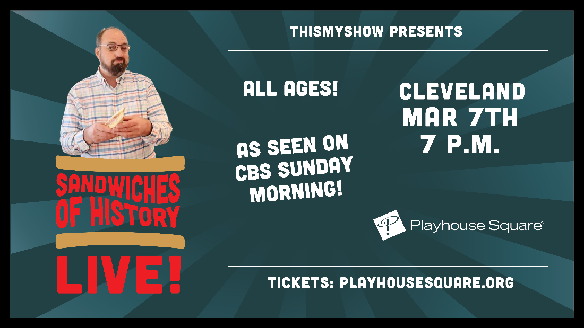

Sandwiches of History: LIVE!
The Internet Sensation Comes to Playhouse Square on March 7
in a Brand-New Live Experience

Cleveland, OH - Ah, sandwiches. They’re everywhere. But what’s the story behind the club, the Cuban, or the hot brown? Through his various social media platforms, Barry Enderwick (@sandwichesofhistory) has been exploring all things sandwich for years and sharing them with followers around the world.

Now to celebrate the release of his new cookbook Sandwiches of History: The Cookbook, Barry is hitting the road to share the history of Sandwiches of History! Each stop will feature special guest stars, live sandwich making and tasting with audience-suggested plus ups, audience Q&A, trivia games and more surprises! Barry has been seen on CBS Sunday Morning, now see him at Playhouse Square on March 7th. Tickets are available for purchase online at playhousesquare.org or by phone at 216-241-6000.

In Sandwiches of History: The Cookbook, for the first time, Barry has taken the source material for dozens of sandwiches and painstakingly recreated them—staying as faithful as possible to every original sandwich, while providing much more guidance on successfully making each one. From the classics to more out-of-the-box sandwiches, Barry provides not only recipes, but interesting information and fun facts that pertain to them.

Sandwiches of History: Live!
Westfield Studio Theatre at Playhouse Square
March 7th, 2025 at 7:00 p.m.
Tickets start at $20.

# # #

Playhouse Square, home to the largest Broadway season ticket holder community in North America, is Northeast Ohio's destination for entertainment. A not-for-profit performing arts center, Playhouse Square is a champion of arts education and downtown Cleveland, and proud to be the home of The City Club of Cleveland, Cleveland Ballet, Cleveland International Film Festival, Cleveland Play House, Cleveland State University Department of Theatre and Dance, DANCECleveland, Great Lakes Theater and Tri-C JazzFest.

