

FOR IMMEDIATE RELEASE:
Media Contact: Emily Christyson
Phone: 216-329-0180
Email: Emily.christyson@playhousesquare.org

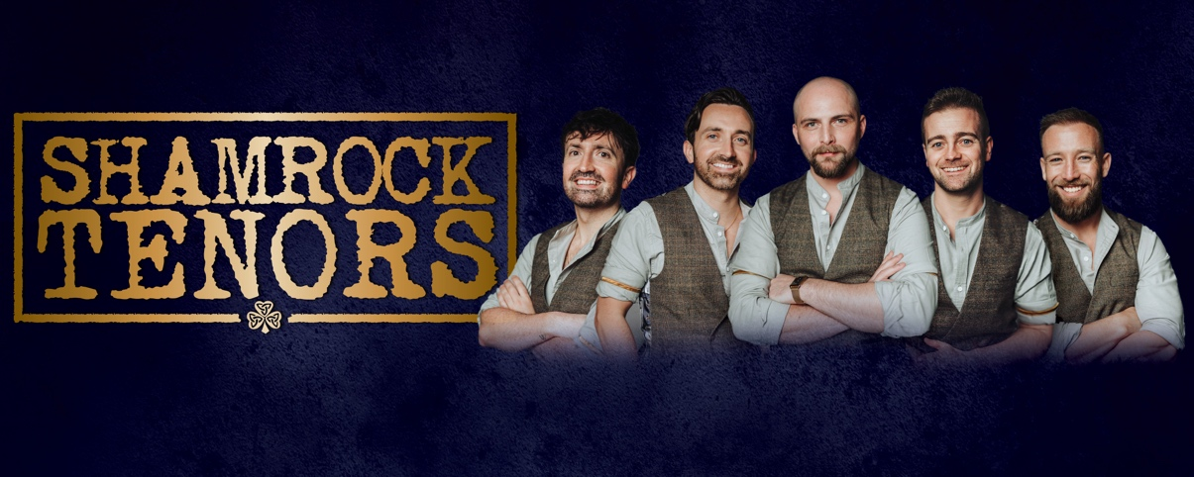

PLAYHOUSE SQUARE presents
SHAMROCK TENORS ON MARCH 23
Direct from Belfast and London’s West End,
the groundbreaking group brings fresh Irish energy to North America

Cleveland, OH -Irish music fans, get ready to be captivated! The SHAMROCK TENORS, hailed as "Ireland's most exciting new folk music sensation," are set to light up stages as they embark on their inaugural North American tour. After selling out venues from Belfast's Grand Opera House to Birmingham Symphony Hall, and performing for 20,000 fans at London's Trafalgar Square, the tenors are thrilled to be making a stop at Playhouse Square on March 23. Tickets start at $45 and are on sale now at playhousesquare.org and by phone at 216-241-6000.

Featuring performers from London’s West End productions like Les Misérables and Northern Ireland's finest multi-instrumentalists, the SHAMROCK TENORS embody Ireland’s rich musical and cultural heritage. Jimmy Johnston, Tom Brandon, Matthew Campbell, Raymond Walsh and Jack Walsh bring fresh energy to Irish music, performing beloved classics like "Danny Boy," "Whiskey in the Jar," "The Parting Glass," and "Wild Rover" in stunning five-part harmony. With a mix of Irish charm, stellar vocals, and electrifying multi-instrumental performances, audiences of all ages will experience the Emerald Isle like never before.

The SHAMROCK TENORS have achieved rapid success both at home and globally. Highlights from their breakthrough year include headlining the BBC's St. Patrick's Day coverage and selling out their West End debut at the Adelphi Theatre in London. Their music has enchanted over eight million viewers online, and their first two singles rocketed to #1 on the iTunes World Music Charts. Their debut PBS special, filmed live and nominated for a prestigious Royal Television Society Award, is a visual and auditory feast.

Supported by Tourism Ireland and Titanic Belfast, the Shamrock Tenors are redefining Irish music for a global audience.

For more information about Playhouse Square please visit playhousesquare.org. For more information about the SHAMROCK TENORS, please visit www.ShamrockTenors.com or follow @shamrocktenors on TikTok, Facebook, Instagram, Twitter and Youtube.

# # #

Playhouse Square, home to the largest Broadway season ticket holder community in North America, is Northeast Ohio's destination for entertainment. A not-for-profit performing arts center, Playhouse Square is a champion of arts education and downtown Cleveland, and proud to be the home of The City Club of Cleveland, Cleveland Ballet, Cleveland International Film Festival, Cleveland Play House, Cleveland State University Department of Theatre and Dance, DANCECleveland, Great Lakes Theater and Tri-C JazzFest.

